02-01-2012

First top image: Na in the plugged trap…



Ok – there is plenty of room for improvement!

02-02-2012

We installed a PVC curtain on the Na laser table, hoping to achieve a better stability of the Na laser output and fiber couplings (polarization!).

Furthermore, we worked on the alignment of the Na top imaging. After improved focusing and ensuring that we have a BEC in the MagTrap we obtain (in-situ):

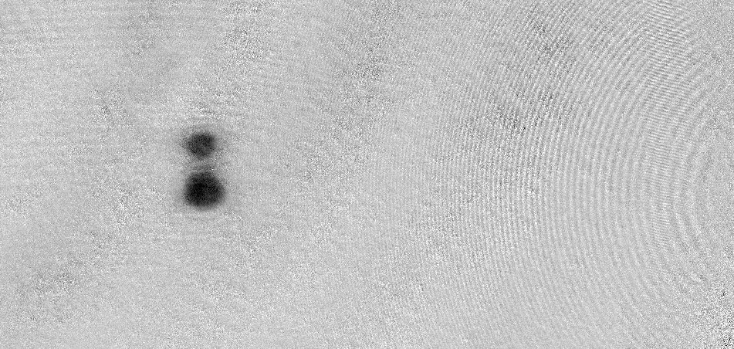

From here we decide that we should do further optimization in the dipole trap. This after all requires alignment of the dipole trap.

02-03-2012

(a) Top imaging beam path…

We inserted a one-to-one telescope in the imaging beam path for TOP imaging: 250 mm – 250mm. This might help us to clean up the imaging beam by placing an iris in the focus of this telescope. However, we realize that the aperture of the usual irises are too large to considerably clean the beam. We rather need a defined pinhole here!

Additionally we should get a 1-inch pinhole after the fiber of the imaging beam. We seem to clip considerably, although the remaining fringes on the imaging beam are likely to originate from interference in the bucket windows…

The quality of the imaging beam improved a lot, when we cleaned and undusted the optics in the path. Most notably the “sausage-slice” mirror underneath the chamber and the top bucket.

(b) Sodium laser table

We optimized the polarization in all relevant fiber couplings.

We observed noise on the Raman amplifier output power. It has a square pulse shape… weird! This happens when the laser runs in power stabilized mode, while in current stabilized mode it is better.

(c) x-imaging with Sensicam

We installed the “Sensicam” along the x-axis imaging path so that we can use it to align the plug:

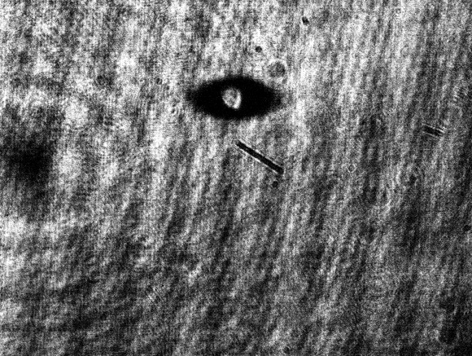

Unfortunately, the software that comes with the camera can only take single shots, so we only take the with atom image to align the plug – not great, but does the job!

Ariel is updating his “simplicio” imaging software so that it can also work with our Sensicam. Peter will help out.

(d) Getting a BEC in the mag trap

It turned out to be critical to **increase the RF power** to gain a healthy condensate in the plugged trap.

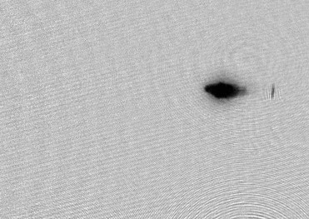 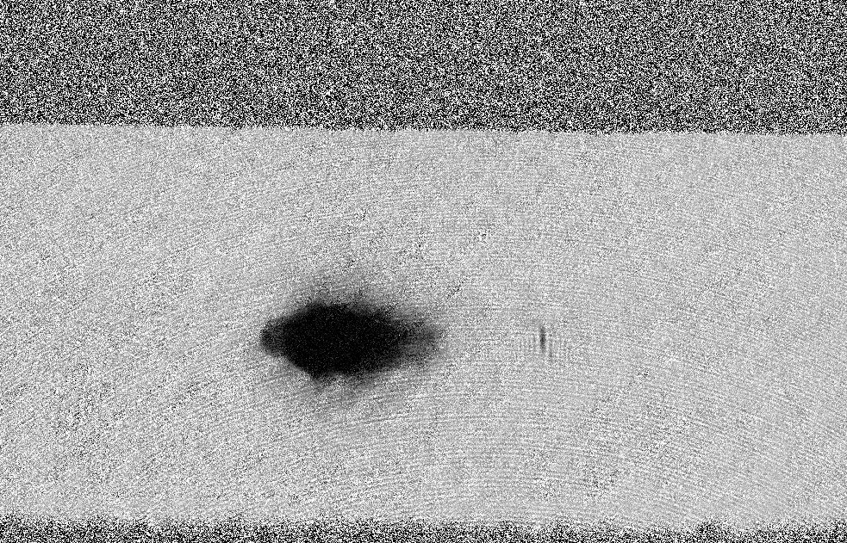

With this change actually everything seems back to normal again ☺

(e) Interference fringes seen from (unfocussed) top imaging after 12ms time of flight:

For the supposedly in-situ position of the top focusing lens we read off the

lens directly in front of the camera!)

(f) Alignment of the dipole trap:

We determine the plug position of the zCam: X 266, Y 582

We align with the new zCam and the yCam. Seems to work reasonably!

02-03-2012

(a) Work on a clean zCam imaging beam.

We locate the image plane that arises in the vicinity of our one-to-one (250-250) telescope. Since the second 250mm lens on the way to the chamber is presumably 400mm away from the atoms, the effect of this lens comes close to that one of a 2f imaging system. Therefore, we expect the imaging plane to be pretty close to the position of the other lens of the one-to-one telescope.

We search for the imaging plane using a very sharp razor blade and locate it to be very close to the assumed position ☺ It is outside of the telescope, just in front of the first lens [at this position we actually wanted to put the dichroics to overlap the 40K beam, but well… We’ll have to find another position for it.]. Here we place an iris, and indeed the imaging beam looks again a bit nicer ☺. Still we have quite a lot of dust on the beam, most of it probably from the top bucket :s To get awesome quality, we probably have to clean this sooner or later…

(b) Curing the offset drift in the 40K RF lock

Turned out that a broken (really broken!) SMA cable between the fast photodiode and the electronics box was causing the rapid drifts of the lock offset… exchanging the cable solved the problem.

(c) Trying to get back potassium…

Unfortunately, this is our poor potassium MOT:

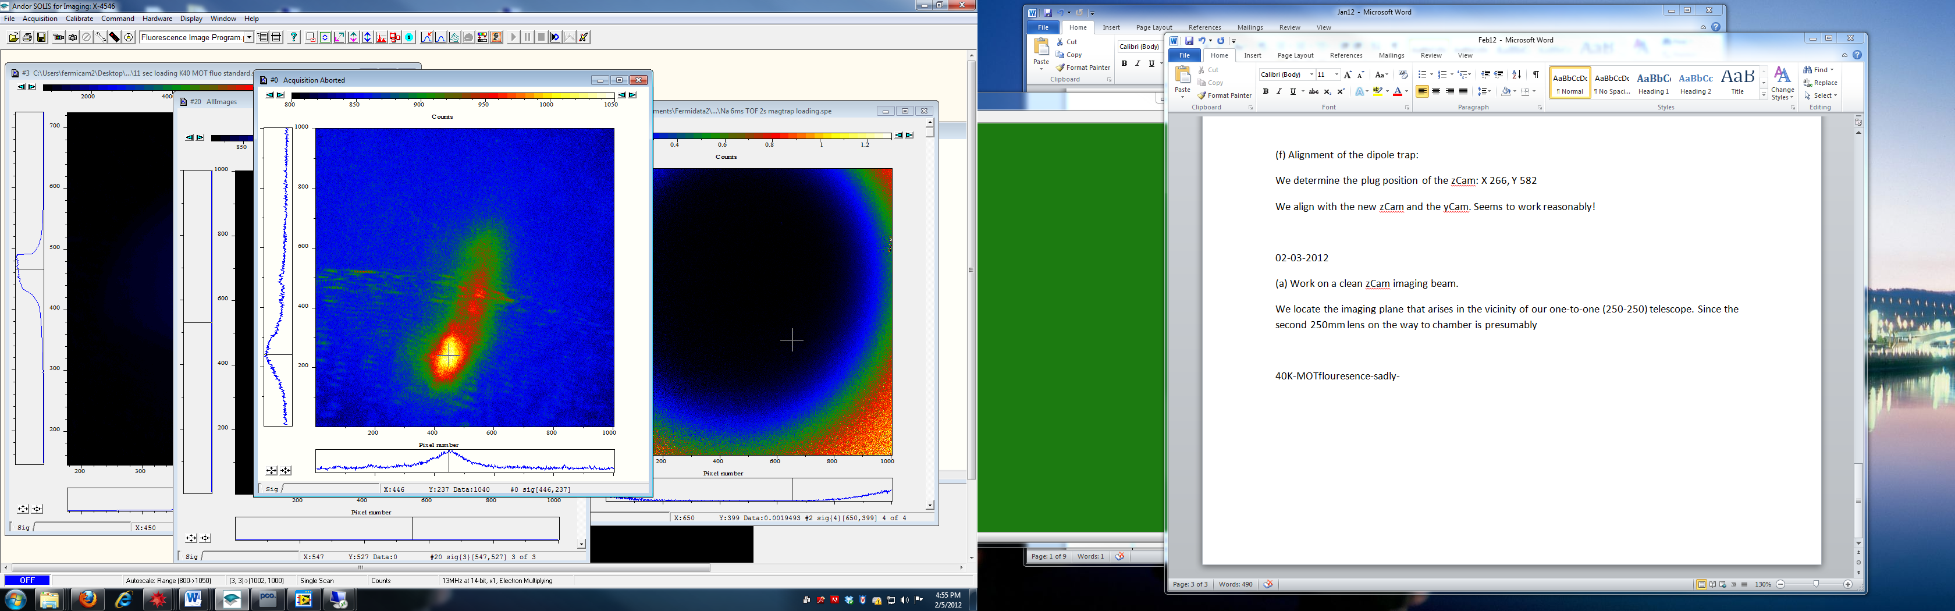

Suspiciously, we can clearly improve on the MOT fluorescence (and actually the captured atom number) by lowering the MOT TA power… that can only mean the beam balance is clearly off or the alignment is poor. Shit…

We tweak the bottom MOT beam and see considerable improvement:

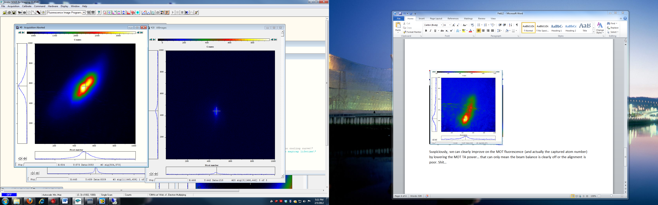

After tweaking the panel we are half way through in reaching the “old” flouresence standard:

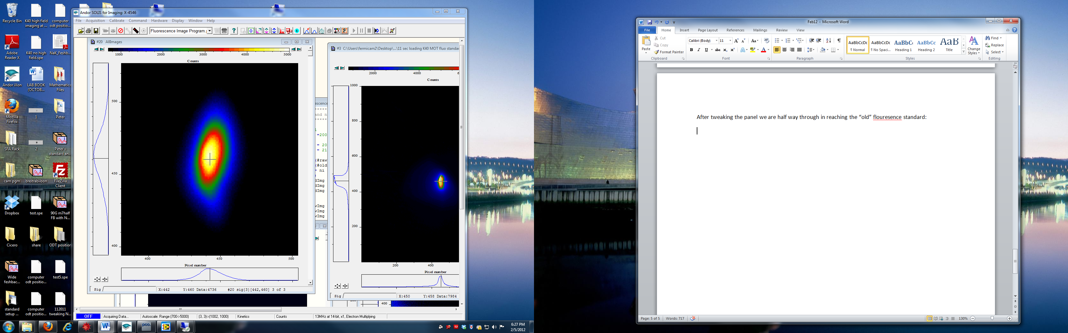

We will check in absorption, if this offers sufficiently acceptable working conditions to get started with the RF!

02-06-2012

(a) Getting Na – 40K RF sequence back:

The old transfer parameters from +9/2 down to -5/2 at 126 G high-field, using an AGILENT AWG:

Start: 58 MHz

Stop: 32.9 MHz

Power: +2dBm

Sweep time: 300 ms

Feshbach Power Supply: control voltage 2.1V

Position of 40K in +9/2 state in Stern-Gerlach: 699/225

+7/2 state in Stern-Gerlach: 674/229

+5/2 state in Stern-Gerlach: 651/225

+3/2 state in Stern-Gerlach: 627/225

+1/2 state in Stern-Gerlach: 599/229

-1/2 state in Stern-Gerlach: 581/229

-3/2 state in Stern-Gerlach: 552/229

-5/2 state in Stern-Gerlach: 529/230 (lower freq 34 MHz)

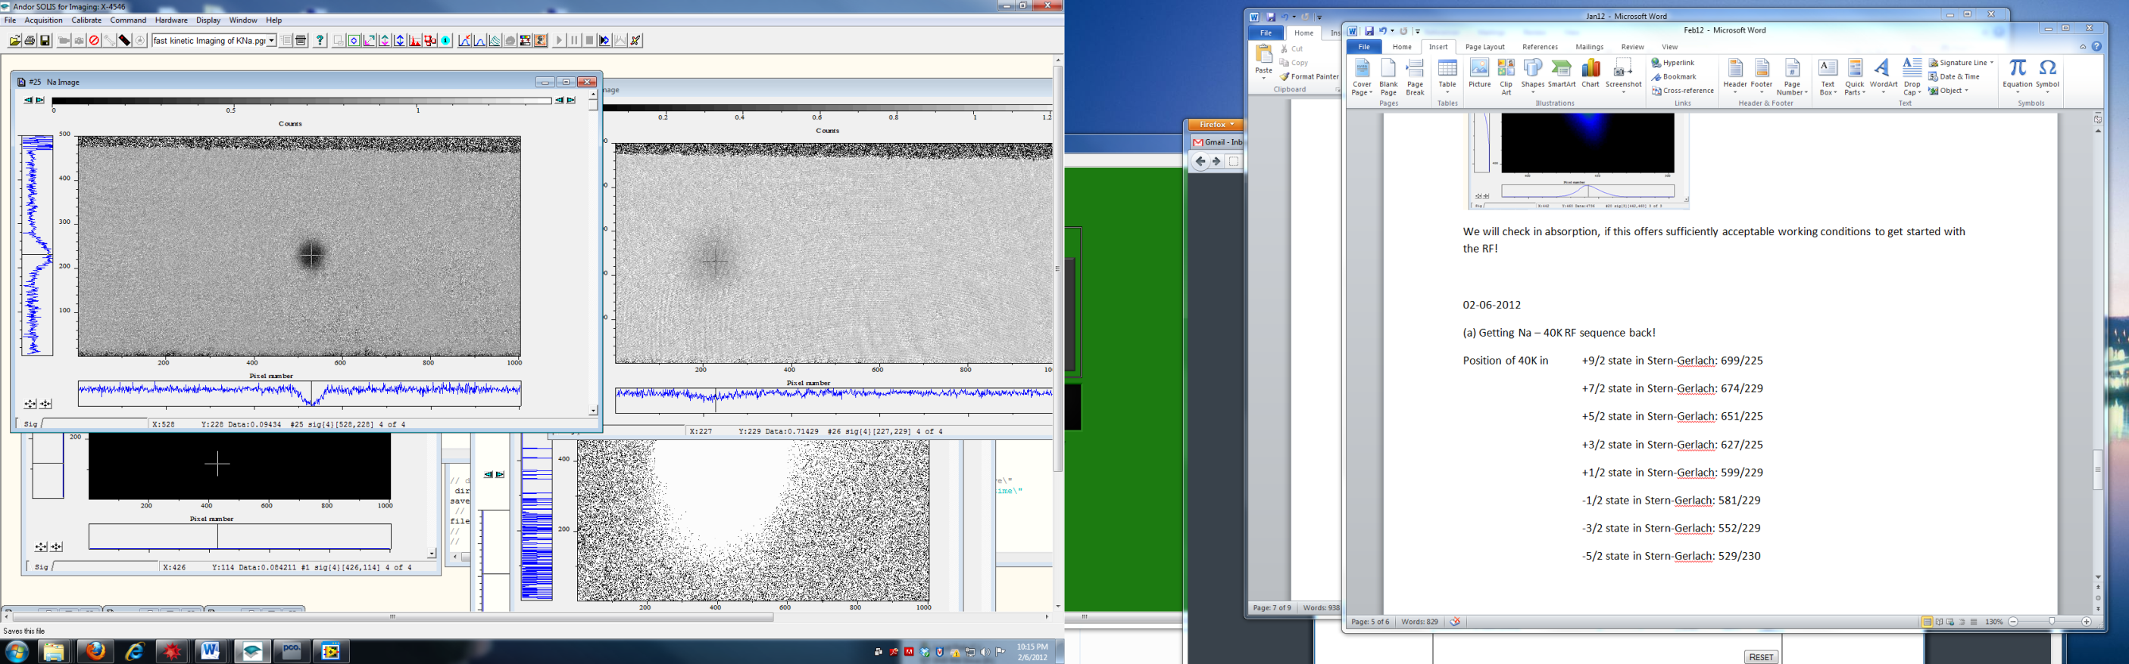

Full transfer to -5/2!

(Note: B-field must be reversed to be on cycling transition for imaging.)

-7/2 state in Stern-Gerlach: 502/230

-9/2 state in Stern-Gerlach: 479/230 (lower freq 30 MHz)

(b) Getting started on setting up the

GPIB works ☺

Imaging frequency for -5/2 at Feshbach 2.5V (about 150G):

ImagTanFreq 212MHz

…and for -7/2:

ImagTanFreq (roughly) 230MHz

ToDo:

* More light for 40K TOP imaging
* RF amp for about 30MHz
* More atoms ;-)

02-07-2012

Sketch of RF distribution (for Sebastian ;-) )

Switch 2

Inner antenna

Dump

AMP

SW5

SW4

Outer antenna

Switch 3

Switch 1

RF 3

RF 1

RF 2

Setting up the sequence:

Is it a good sign?

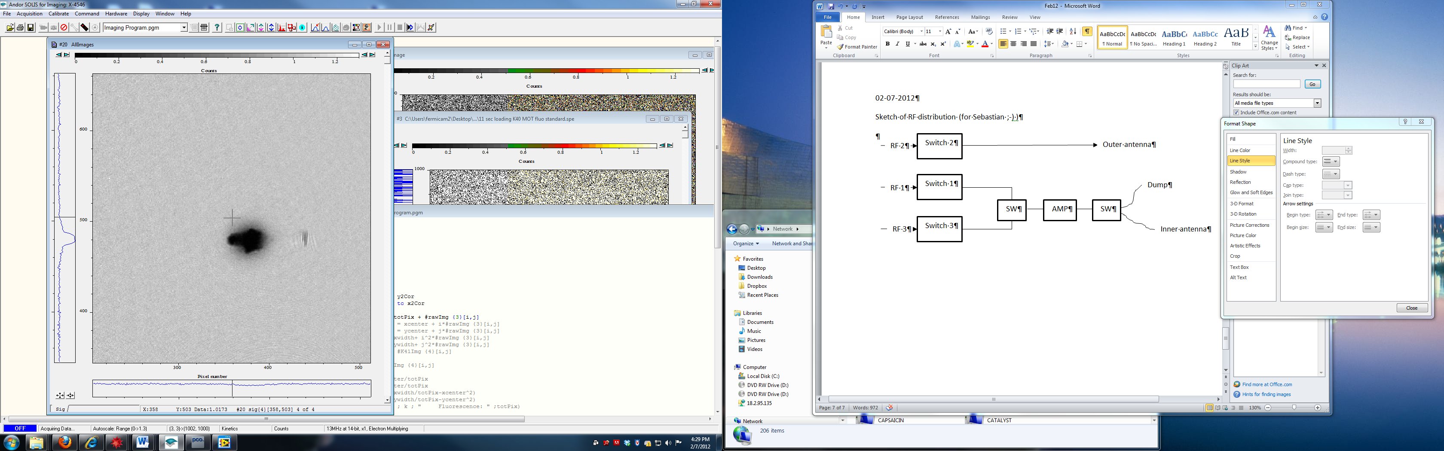

;-)

Several improvements and changes to the preparation sequence for the high-field NaK mixture:

* The TTL that switches the SW5 in the RF tree (see above) is now also connected to enable the AMP at the same time.
* We use GPIB to program both Agilents, i.e. the one to makes the LZ sweep from +9/2 down to -5/2 and the actual “Probe-Agilent” that goes from -5/2 to -7/2
* 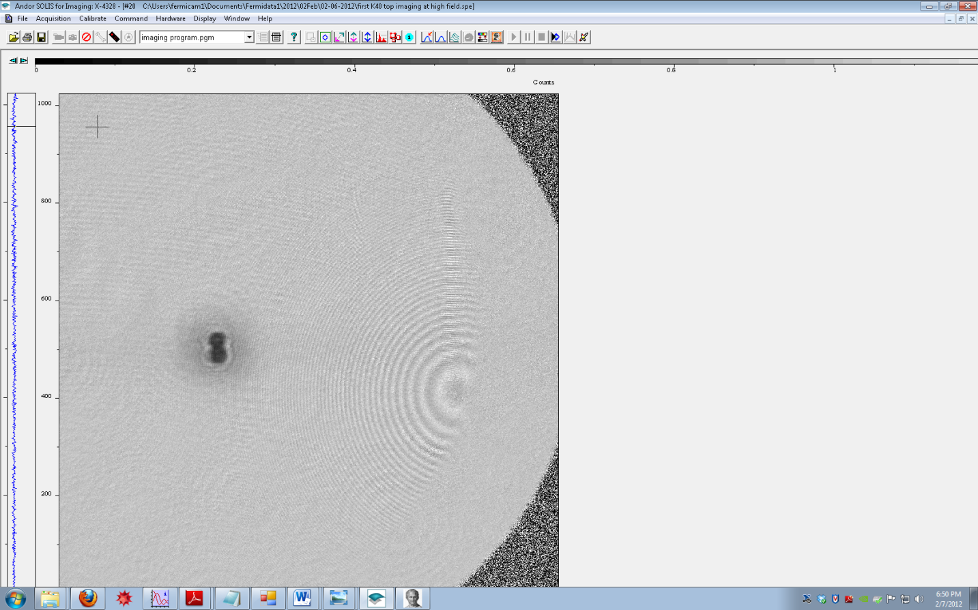We do high-field imaging of 40K on the yCam. After switching off the FB field and 10ms TOF we also take an image of Na at low field. This will help us to ensure that we always have enough Na during the sequence. When looking from top we actually make the observation that our Na condensate has a dent, which very probably originates from the plug beam:

This image is taken from top after 10ms TOF. So, we should insert the plug shutter to ensure that the dipole trap is smooth and harmonic in future experiments!

1. High-field imaging of -7/2

We try to image K40 in the -7/2 state at FB field of 2.5V. The imaging frequency is

ImagTanFreq 227.5MHz.

1. Setting up the sequence for the molecule scan:

From our ramping data in January, we try to make an educated guess, which field would be good to try for the search for molecules:



Old data from January!

So, we are tempted to believe that we are slightly below the resonance for **1.85V.**

Note: that **0.05V control voltage** should correspond to **about 3G.**

When setting up the sequence, we observe that it is super critical to open the RF switch RF4 early enough before we actually want to use the Agilent to do the RF, otherwise it may not be safely open… So, we realize: Opening 20ms before seems kind of safe.

We now aim at a RF scan at 1.85V control voltage!

The bare atomic transition from -7/2 to -5/2 can be narrowed down to a window of between

**29.88 to 29.85 MHz (4dBm)**

(at 1.85V FB control voltage [However with “Bx on = 7.3V” and “By on = 1.5V” *switched on* :s ])

…corresponding to a magnetic field of **112.9 G**.

We now want to scan this purely atomic feature using 20kHz wide sweeps within 5ms.

RUN 1: RF power 0dBm, 20kHz wide sweeps 🡺 transfer seems strongest at around 29.6MHz

RUN 1b: Same as RUN 1, however, WITH Na!!!

* We already see that the transferred 40K atoms in the -7/2 state (probably from the bare atomic transition) do coexist with the Na atoms close to the Feshbach resonance for a little while (BTW: Already for imaging the B field quickly shoots up, which is probably good!) **This is a good message!** So we don’t have to be too concerned that all transferred atoms are just gone due to bad collisions close to the resonance… Promising ☺
* Do we even see a molecular transfer at around 29.9G?? It’s hard to say… we are seemingly insanely power broadened.

RUN 2: Same as RUN 2, however, with longer and properly ordered list of frequencies

ToDo:

* Make the RF transfer pulse as short as possible…
* Try to make the high-field imaging directly after the transfer sequence. Since we are directly at the Feshbach resonance, the lifetime of -7/2 40K atoms is expected to be super short; also the life time of our molecules may be super short… The shorter our sequence, the higher the chances to see transfer. [This will be also true, when measuring the polarons…]
* Frame transfer imaging, so we can do high field imaging both for the -7/2 and the -5/2 state. The frequency of the tandem can be switched very quickly. Imaging both spin states would be very good to obtain the normalized transfer! Will be certainly necessary!
* Work at stabilized B-field…
* …and, of course, more and slightly colder atoms (but probably not too cold) ;-)

**02-10-2012**

* We made a panel which takes a fluo image of K40 with our up-to-date NaK panel. Using this pane, we tried to understand whether secondMOT loading trick is improving K40 atom number, and if yes, by how much.
  + We noticed that secondMOT loading trick with Na spin cleanup only improves K40 peak fluorescence after magtrap capture by at most 30% compared to without Na spin cleanup, contrary to our past belief. Whether we do Na hyperfine pumping and/or mF pumping does not change this efficiency much.
  + However, doing Na spin cleanup does improve Na atom number quite a bit (possibly more than 50%)
  + Presence of Na does affect K40 loading, by about 30% when Na is fully loaded. We observe this by comparing with and without Na K40 fluo images after magtrap capture
* We noticed that the LiNa slower magnetic field must be turned on during K40 MOT loading. This can be due to our current bias field settings. We may want to fix this in the future. In fact, we should be more cognizant about what we do with bias fields, esp. during MOT loading and pumping stages.
* In any case, we tweaked up the machine to pre-Na laser breakdown stage. Now we have a Na BEC with a decent K40 cloud in p9half:

02/13/12

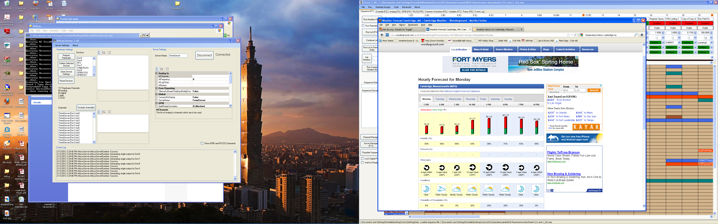

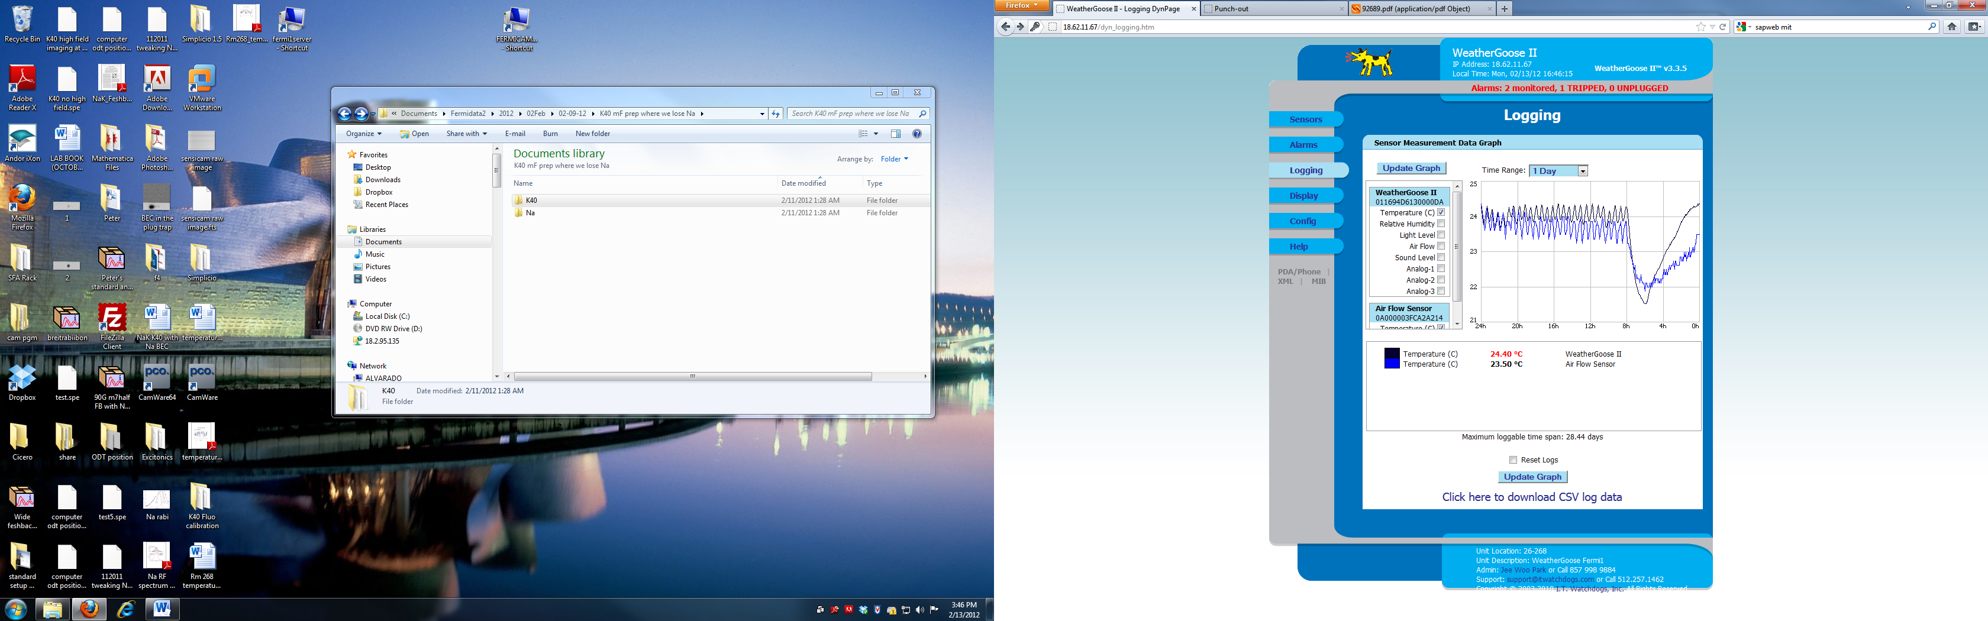

It seems that the lab temperature fluctuation doesn’t correlate with the outside temperature. At 7am the outside temperature raised but we observed a sudden drop in the lab temperature. We suspect that the heat water temperature drops in order to compensate the weather change but our air conditioning system can’t response fast enough.

**Search for molecules between Na (1,1) and 40K (9/2,-5/2)**

We prepare a mixture of Na (1,1) condensate and 40K (9/2,-3/2) at a field of around 138 G. The setpoint for the Feshbach field (front panel controlled) is:

4.7 V

4.58489 V DanPhysik

(a) Finding the bare atomic transition for -5/2 to -3/2:

By doing LZ sweeps we narrow down the atomic transition to between 37.020 MHz and 37.030 MHz at sweep time 5 ms and power -22dBm.

First we try to map out the 40K alone spectrum by applying a 200ms RF sweep. Each sweep is 20kHz wide. This is the spectrum we took (the measurement was done at 138G, the parameters above):



Then we put in Sodium.

|  |  |
| --- | --- |
| 40K loss spectrum: | Na loss spectrum: |
|  |  |

The graph below shows the 40K atom number ratio. However, it’s not trustable since around 37MHz there is almost no atom left. (zero/(zero+zero) =0.5)



Now the question is : why Sodium can broaden the spectrum ????

(b) High-field imaging sequence

In addition to the above sequence in low field imaging, we perform high-field imaging of both K spin states at high-field (138 G) with fast kinetics mode on the yCam (TandemFreq 209MHz [-3/2] and 223MHz [-5/2]). Unfortunately, the signal is quite a bit worse than low field imaging, since the polarization is not perfect [B field is along the z direction!] and we are not in the high-field limit, e.g. we probably do not have a perfectly cycling transition. Besides K, we also monitor Na on the zCam.

Here the actually do much shorter 30ms, fixed frequency RF pulses at a power of -5 dBm.

We make the following interesting observation:

- around 37 .00 \pm 0.05 MHz we observe no Na condensate (imaged at low field!), while we see a clear signature of transferred K (in the -5/2 state) at high field - in contrast to the low field procedure above. This might be consistent with the presence of molecules?

- above 37.05 MHz we see a Na condensate appear again with transferred K at the same time. For even higher B fields the condensate is very healthy and the transfer of K pretty much stops.

- when doing Stern-Gerlach at **high-field** it sometimes seems that the atomic peak in the -5/2 images is a little bit more dislocated. We estimate that the NaK molecules has a SG acceleration that is only 10 per cent higher than that of a the bare K (-5/2) atom. Therefore a location of the molecules very close to the atomic position can be expected in SG.

(c) Summary for today:

- We see an amazing influence of the presence of the condensate on the resonance feature of the K transition. It means we are in a rather strongly interacting regime. This is good. Furthermore, we have some hints that a molecular state may not be far away…

[Side remark: Images with bare K after sympathetic cooling with Na look rather juicy and cold. Not bad at all…, clearly no Gaussian clouds]

**What can we do:**

- Take the same data as above (a) just for a slightly different field (e.g. 2G lower). Try to see any changes with the field

- Shorten the transfer sequence to make sure that molecules are not lost before detection! Possibly a pulse duration around 1ms at fairly high power would be doable. [Nevertheless, our high-field imaging ideally would lead higher signal - possibly do it on zCam?]

- For the bare molecular signal: Possibly we can work with higher atom number, but without condensates…

02/14/2012



The atomic transition is at around 34.03MHz (corresponding to 125.296G) and the molecular binding energy amounts to about 300kHz.

An amazing day ☺

02/15/2012

**Try to see the molecular signal in RF spectra at different fields**

(a) We had about 125G (4.1521V on Danfysik) yesterday. Let’s now go for about 122.5G corresponding to about 4.0291V on Danfysik.

Position of -3/2 at 493/202 after SG.

Position of -3/2 at 433/180 after SG.

The bare atomic transition:



The transition frequency is at about 33.21 MHz (corresponding to 121.768G). However, in the presence of a juicy sodium condensate we see the following:



We see a shift of the atomic transition by about 20 or 30 kHz (“corresponding to 121.64G”). Furthermore, there is a clearly discernible low frequency tail (polaronic) to this peak.



The molecular transition corresponds to a binding energy of about 750kHz.

(b) Now, we try to see everything at a slightly higher field, closer to the FBR (4.1896V on Danfysik) This corresponds to about 126 G.

The atomic transition is at about 34.30MHz (corresponding to 126.464G):



We get the following signal for the total 40K atom number (both boxes for -5/2 and -3/2 summed up):



The data is averaged over three individual runs. The (almost uniform) noise originates from global atom number fluctuations of 40K. The temperature in the lab fluctuated by at least 2 degree Celisius.

The binding energy corresponds to roughly 220 kHz. The atomic transition appears slightly shifted at about 34.28 MHz (corresponding to 126.378G).

(d) Try to observe molecules in high-field imaging

Initial position of the lambda/4 on the y-imaging axis: 192 degree

New (hopefully optimal ;-) position of wave plate: 183-185 degree

Signal is unfortunately too low: bad coupling due to wrong polarization and too low 40K atom number after all the temperature changes in the lab. A bit sad…

(e) Summarizing the current binding energies versus B-field, this is what we get:



So, it seems the actual resonance position lies way higher than 130 G… [in our paper the center is quoted as 148 G. That might however be a bit too high…]

**ToDo**:

* Tweak pumping power for 40K!
* Arrange a more “gentle” transfer sequence, that allows to detect a narrow molecular peak (like a pi-pulse for the molecules!)
* Why don’t we try atom-molecular Rabi oscillations? We should be in very good shape, given our nice field stability

The evolution of RF loss spectrum of 40K m3half state

|  |  |  |
| --- | --- | --- |
|  | With Na BEC | Bare 40K spectrum |
| 138 G |  |  |
| 135G |  |  |
| 126G | 200kHz |  |
| 125G | 300kHz |  |
| 122G | 800kHz  Arrival spectrum:    We see the clear asymmetric tail at atomic transition. Is it repulsive polaron ? |  |

02/17/2012

Initial position of lambda/2 determining pumping MOT and pumping REPUMP power ratio: 97

Initial position of lambda/2 splitting imaging1 and imaging2: 252

02/20/2012

(i) 40K atoms (-3/2 state) observed in top imaging, yet, unfocussed.

(ii) Na BEC observed in top imaging after 1ms TOF, now, focussed!

(iii) Na BEC observed in top imaging in-situ, again focussed!

Three awesome messages:

(a) It seems 40K high-field imaging works much better on the zAxis (compared to yAxis). Although the image (i) is not yet focussed, the signal is decent.

(b) To focus top imaging, we produced a nice and pure Na BEC. We realized that focussing is not possible, when the presence of the plug beam distorts our cloud uncontrollably. Hence, we installed a shutter for the green beam. Immediately, we observed very nice oval clouds after time of flight. The images indicate an anisotropic crossed dipole trap, which we now can also easily make round, if we want or need to.

(c) The focussed BEC images (ii) and (iii) already give a hint of the great resolution that we now have on the zAxis. The edges of the condensate are super-sharp and fall off within one or two pixels (one pixel corresponding to about 2.5um)...

Now, it's gonna be exciting to see how high-field kinetic imaging for 40K will work! If it does, it's gonna be fantastic!

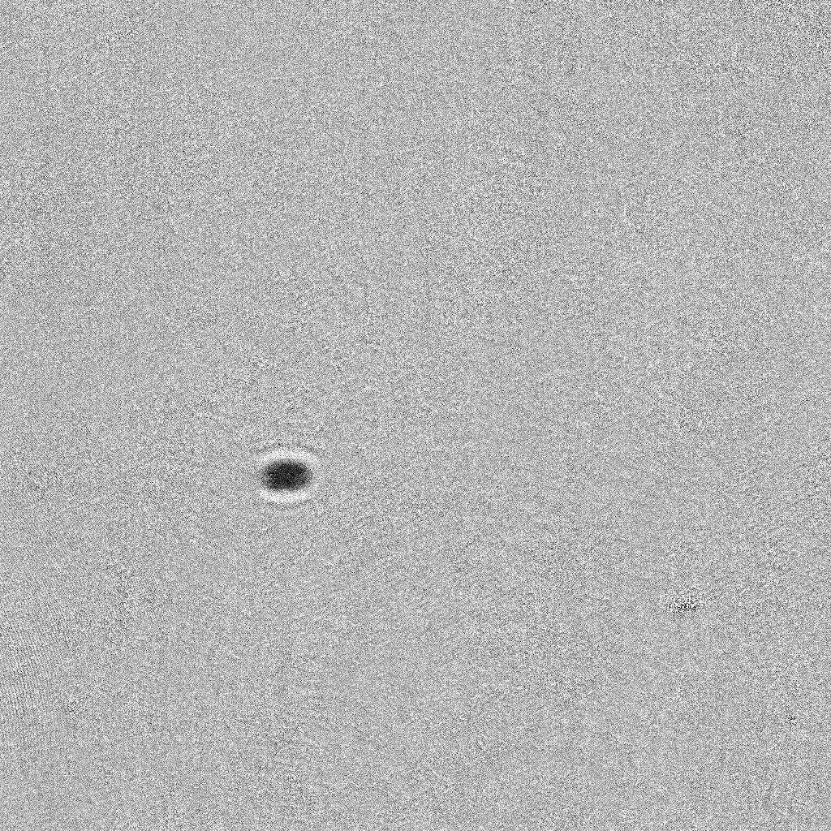

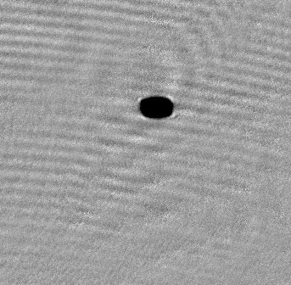

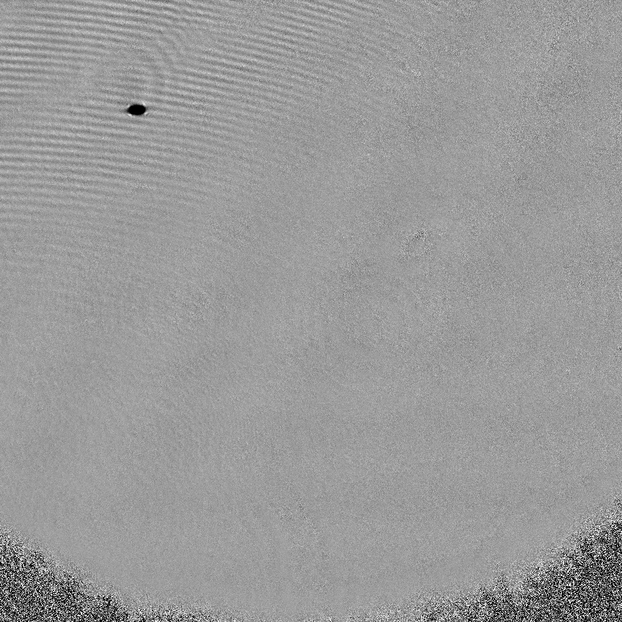

02/21/2012

We got the 40K high field top imaging working. It’s much better than the y imaging high field. See the image below

TOP imaging at 126G (9/2,-3/2)

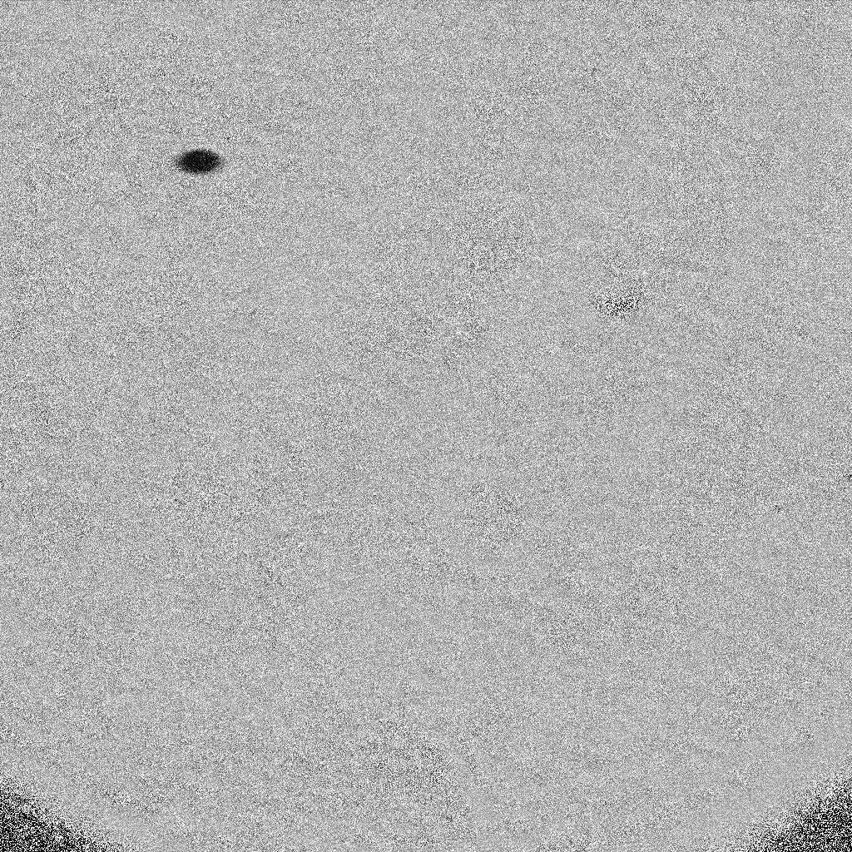

02/23/2012

Somehow using the 9/2,-3/2 light we can also see 9/2,9/2 at 129G with kind of strong signal !! Coincidence?

We realized that the reason why we were not seeing molecules could be we were not yet in the halo dimer regime in which one can use bare atomic transition frequency light to see the molecules. We tried to go closer to the FB resonance and we realized that there was a resonance at 129.5G in the 40K <9/2,-1/2| state after seeing strong atom loss. We then went to even higher field to 132.5G and took the following spectrum.





Then we tried without BEC:

Bare 40K spectrum



40K spectrum with Na thermal cloud



2/24/2012

(very strong) Hint of molecule production at 132.5G with thermal Na:

1. K40 arrivals to m5half with Na thermal at 132.5G compared to K40 alone   
   
2. Na loss near 35.75MHz (could be “transparency” and not “loss”)



1. Temperature of Na sharply drops off after 35.77MHz

At this point, the K40 bare transition width is too wide to make a definitive conclusion, but all of the evidences point towards producing NaK molecules using thermal Na. Our next mission is to make our features as narrow as possible. For starters, we can try to measure K40 loss vs. rf freq. using long and weak rf pulses (narrow Fourier width, narrow power broadening).

02-27-2012

We setup the double kinetic mode on the top camera. The following graph shows the bare 40K m3half to m5half transition but the ratio was done with m5half and m1half (we spin flip m3half to m5half to avoid remaining background on the m5half imaging). We see clear sinc feature; however the spectrum looks asymmetric which could be a hint of molecules??

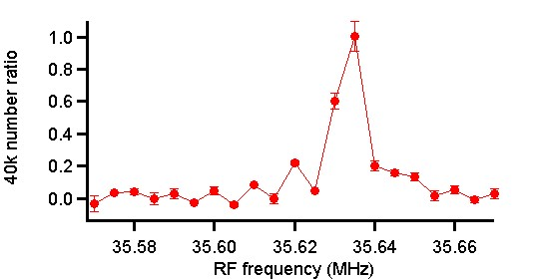

02-28-12

We first train ourselves with bare 40K m3half to m5half transition. The spectrum below was taked with 100us pulse time. As you can see, it’s a beautiful sinc function.



(fit function f(x) = A+B*sinc(sqrt(C^2+(x-D)^2)*E)^2)

And then, we threw in sodium. Please see the spectrum below. We haven’t observed the molecule peak. Maybe the temperature was too high or sodium number was too low?



OK. We decided to try using Gaussian envelope pulses. We use one more Agilent to generate the Gaussian pulse shape, we externally trigger this Agilent which then modulates another Agilent which provides the carrier frequency (i.e. actual RF pulse frequency for transition).

The settings for the Gaussian envelope Agilent are as follows:

Arb🡪waveform “GAUSS2”; 5 Vpp; 0 V offset; period = rf pulse duration

Burst🡪”N-cycle” setting with 1 cycle; 0 deg phase offset

We implement the Gaussian envelope pulse (blackman pulse) and obtain the non-sinc spectrum as below (100us 9dbm):



Bare 40K spectrum with 200us 20dbm pulse:



YAAA!!! WE SEE THE MOLECULES::















We tried to see the atom-molecule Rabi oscillation and we measured this :

What is going on???



We suspect the oscillation comes from the sinc lobes emerging in periodically so we took the data again without Sodium..

Okay…It is the sinc



We then tried to use blackman Pulse to do the Rabi Oscillation:



Longer wait time:



Conclusion: We haven’t observed Atom-Molecule Rabi oscillation….

What is the NaK molecule lifetime? We create the molecules by 1ms sweep from 35.696MHz to 35.673MHz



03-02-12

We tried to blast Na BEC away at high field in order to enhance NaK molecule lifetime and we see this interesting cloud when the power is kind moderate.

Our guess is the ring size is given by the R = (photon momentum/Mmass_Na)*TOF

